**State Space Problem Solving Model for the Missionaries and Cannibals Problem**

1. PROBLEM STATEMENT  
   There are three Missionaries (M) and three Cannibals (C), and one boat on a river that fits at most two people. At least one person is required to operate the boat. All six missionaries and cannibals must safely cross the river – under one condition; at no point should the number of cannibals outnumber the missionaries at any spot (left bank, right bank, boat) – otherwise, the missionaries will be consumed.
2. THE OBJECTS OF THE WORLD
   * Three Missionaries
   * Three Cannibals
   * Three spots: The boat, the left bank and the right bank
3. REPRESENTATION OF A STATE IN THE WORLD
   * Let *m* be the number of marines in a given spot
   * Let *c* be the number of cannibals in a given spot
   * Let *B*, *LB* and *RB* represent the Boat, Left Bank and Right Bank respectfully
   * A state will be represented as: { LB = (m,c) | B = (m,c) | RB = (m,c) | m = 0,1,2,3 | c = 0,1,2,3 | **m ≥ c** | m+c < 2 for B}
4. THE STATE SPACE DESCRIPTION
   * Initial State: { LB = (3,3) | B = (0,0) | RB = (0,0) }
   * Goal State: { LB = (0,0) | B = (0,0) | RB = (3,3) }
5. PARTIAL STATE SPACE GRAPH/TREE
   * State Space Operators:

(**1**) Place 1 M and 1 C on boat: LB = (m-1,c-1) | B = (1,1) | RB = (m,c)

(**2**) Place 2 C's on boat: LB = (m,c-2)| B = (0,2) | RB = (m,c)

(**3**) Place 1 C on boat (C already controlling boat): LB = (m,c-1) | B = (0,2) | RB = (m,c)

(**4**) Place 1 M on boat (C already controlling boat): LB = (m-1,c) | B = (1,1) | RB = (m,c)

(**5**) Drop M on RB: LB = (m,c) | B = (0,1)| RB = (m+1,c)

(**6**) Drop C on RB: LB = (m,c) | B = (0,1)| RB = (m,c+1)

*Graph is on next page*

1. 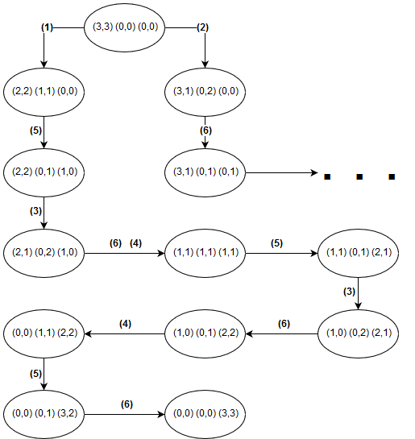STATE SPACE SOLUTION  
   Step State  
    – (3,3) (0,0) (0,0)  
   (**1**) (2,2) (1,1) (0,0)  
   (**5**) (2,2) (0,1) (1,0)  
   (**3**) (2,1) (0,2) (1,0)  
   (**6**) (2,1) (0,1) (1,1)  
   (**4**) (1,1) (1,1) (1,1)  
   (**5**) (1,1) (0,1) (2,1)  
   (**3**) (1,0) (0,2) (2,1)  
   (**6**) (1,0) (0,1) (2,2)  
   (**4**) (0,0) (1,1) (2,2)  
   (**5**) (0,0) (0,1) (3,2)  
   (**6**) (0,0) (0,0) (3,3)